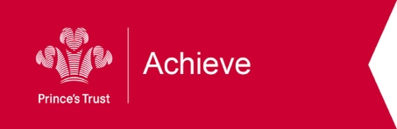
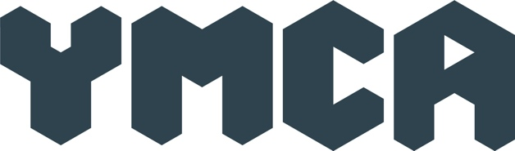
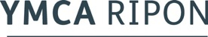

YMCA Achieve Course Information Sheet
Level 1 Award: Personal Development and Employability Skills
The Prince’s Trust qualifications in Personal Development and Employability Skills recognise a breadth of personal skills, qualities and attitudes required by employers across a range of sectors.
They give participants the opportunity to:
- Develop their own personal growth and engagement in learning
- Engage in learning that is relevant to them and support their development of personal skills and attributes that are essential for working life and employment
- Prepare themselves for progression into further education programmes, apprenticeships or other work based learning
The course will run over 6 weeks and will comprise of workshops and one to one sessions. Participants will receive a £20 voucher after participation over two weeks and a further £30 at the end of the project, along with a L1 qualification. Lunch and refreshments will be provided.
Participants need to attend all sessions.
Date | Session
Tuesday 3rd November | Workshop 12-3pm
Tuesday 10th November | Workshop 12-3pm
Wednesday 11th November | One hour session, time tbc
Tuesday 17th November | Workshop 12-3pm
Tuesday 24th November | Workshop 12-3pm
Wednesday 25th November | One hour session, time tbc
Tuesday 1st December | Workshop 12-3pm
Tuesday 8th December | Workshop 12-3pm
TBC | Final one to one session
Due to Coronavirus and safe working practices we will be working with small group of 6 young people, and maintain social distancing throughout the course. Sessions will be engaging and we will work to the individual needs and strengths of participants to help them achieve the Award.
For more information or to make a referral or application please complete the form below and send it to lucy@riponymca.org or phone us on 01765 607609

Ripon YMCA Achieve application
Please complete this form so we can contact you and register you for our course.
Name:

D.O.B: | Age:
Phone No:
Email:
Address

Postcode:

Parent/Guardian/Next of Kin
Name, address, phone number:

Qualification history. Please tell us if you have done any qualifications in the past.

Job history. Please tell us if you have been employed in the past.
Do you know your Unique Learner Number? This is sometimes on any certificates you may have. Don’t worry if you don’t know it.
Unique Learner No:

Health & Wellbeing/Disability:
Is there anything we need to know about you?

Ripon YMCA have developed this project in 2020 in response to unemployment in young people locally. We will discuss your application with you, but this course may not be suitable for everyone.

